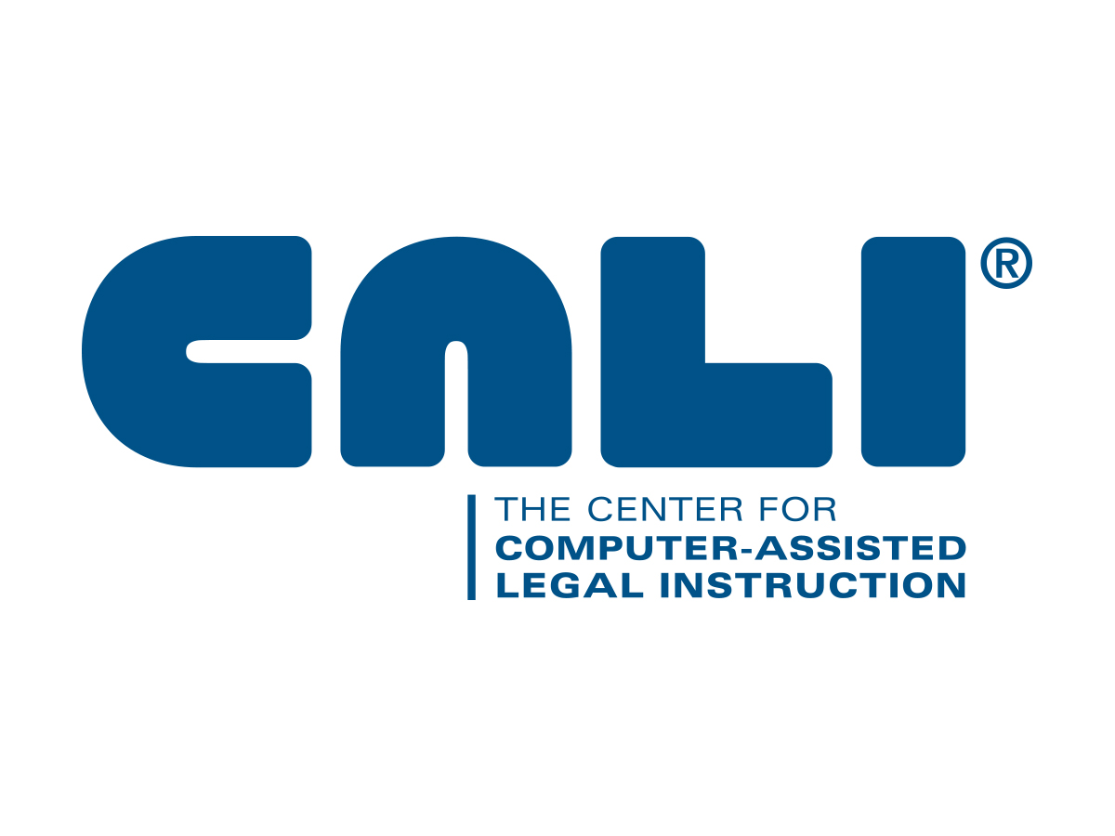
Civil Procedure Fellowships

Now in its 18th year, the CALI Fellowship Project is an applied research effort to create web-based interactive learning materials in legal education that provide alternative teaching materials and formative assessment. The process and the resulting teaching materials will benefit faculty participants, and both students and faculty at CALI member institutions. The resulting materials receive internal review from other members of the Fellowship team and peer review from the CALI Editorial Board. The materials are distributed via CALI’s website as part of the CALI Library of Materials, including free casebooks at eLangdell Press. The goal of the Fellowship is to create a high-quality collection of web-based teaching materials that all faculty can use to supplement their courses or locally customize for specific instructional goals, while providing an opportunity to explore computer-mediated / distance learning in legal education.

CALI is assembling a team of four or five faculty to become CALI Civil Procedure Law Fellows. The Fellowship will take place over a six month period beginning late June 2017. Selected Fellows will receive training and any support necessary to individually author four or five CALI Lessons.

Prior to submitting your application, please review the CALI Topic Grid at http://www.cali.org/content/cali-fellowships and the article, “The Origin of the CALI Topic Grids” linked at this webpage. These materials will provide a historical grounding of the Fellowship.

Please send a statement expressing your interest and reasons for participating, along with your c.v. to Deb Quentel, Director of Curriculum Development, CALI, <dquentel@cali.org>

- Application Deadline: May 24, 2017. With notification by June 8, 2017.
- Applicants must be full-time faculty at CALI member law schools for 2017-2018.
- CALI Author software is Windows based. You must have access to a Windows computer.
- We are seeking faculty with extensive experience (5+ years) teaching Civil Procedure.
- CALI Fellows will receive up to $6,250 from CALI for their participation.
- Fellowship time commitments will average 4-5 hours/week over 6 months.
- CALI provides a sufficient travel budget for each Fellow for the three, mandatory meetings. Each meeting begins in the evening of day 1 and continues through dinner of day 2. Each meeting will take place at a date to be mutually agreed upon by all team members and often at a different Fellow’s law school. The anticipated schedule is as follows:
- First meeting and training: late June or early July 2017
- Second meeting: late August or early September 2017
- Final/third meeting: January 2018 during AALS in San Diego.

Please contact Deb Quentel at dquentel@cali.org / or 312-906-5353 for more information.

